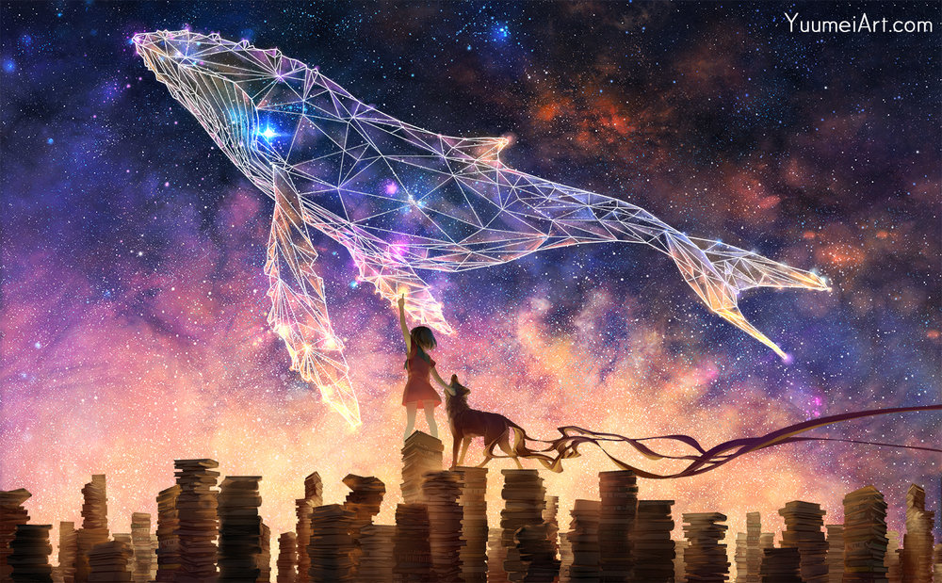

Questions to help inspire you:
- What do you think is happening here?
- Why is the title ‘Dream Big’?
- Is the girl touching the stars? Did she draw the constellation?
- Is the animal beside her a dog? A wolf? Something else?
- Why does it have trailing lines? Is it real? Is it her pet? Could it be a dæmon, like in Northern Lights?
- Why are they standing on piles of books?
- Does this picture have a message? What could it be?

