Year 5 Home Learning Checklist
Word of the Day:
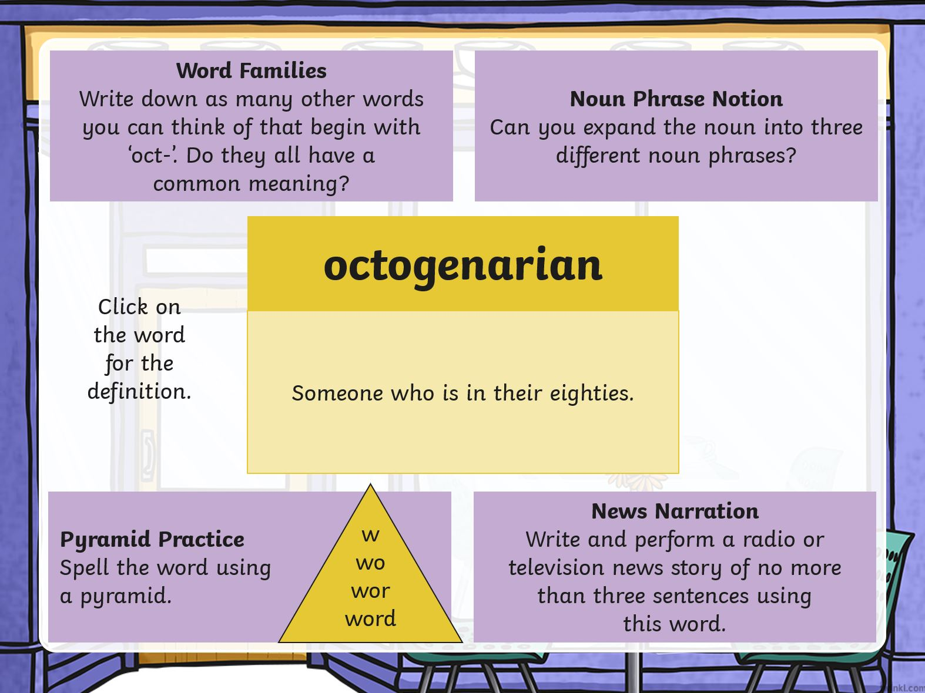
Today’s activities are: | ✓
English:

Writing:

Look at the picture stimulus on the website and consider what is going on in the picture. Use your imagination as much as possible and try to use as many different types of sentence spider legs as you can. Write a short story or diary entry as one of the characters. There are some questions to help inspire you. We have attached the sentence spider on the post on the website for you to help.

Reading:

Please find the reading comprehension attached in the resources on the website post.

Remember to read the text first and then the questions carefully. You should try to answer in full sentences as much as possible.
Maths:
This term we are going to be looking at Geometry. We have set you a few tasks on MyMaths covering some recap aspects of Geometry you will be learnt in previous year groups.

Can you remember the different types of triangle and how you identify them?
How do you know which type of angle you are looking at?

Please click here for the slides today.
https://app.mymaths.co.uk/1755-lesson/angles-1
https://app.mymaths.co.uk/1752-lesson/angles-2
https://app.mymaths.co.uk/244-lesson/properties-of-triangles

We would like you to have a go at ‘Angles 1’, ‘Angles 2’ and ‘Properties of Triangles’ set for you.

Remember to log into MyMaths using the school username (eshercs) and password (symmetry) first before using your own personal log in details. There is a guide to using MyMaths today’s post should you need it.

Big Enquiry/Art:

This half term we will be studying the Partition of India. When you first think of India, what comes to mind?

We would like you to have a think about this question and then use a media of your choice to create an image that represents India. You might choose to do a pencil sketch, a painting of what you think the landscape looks like or a 3D model of a statue you associate with the country. Please try and think carefully and be creative.

Remember to give yourself a tick if you have completed these activities too (you do not need to do all of them every day!):

 | Read for at least an hour |  |  | Practise your mental maths (on TTRS)
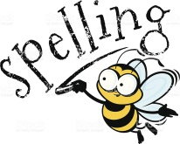 | Practise your passport spellings (on Spellzone) |  |  | Practise your handwriting
 | Keep active and exercise
Have a great day,
Mrs Brown and Miss K .

