Year 1
Autumn Term 2

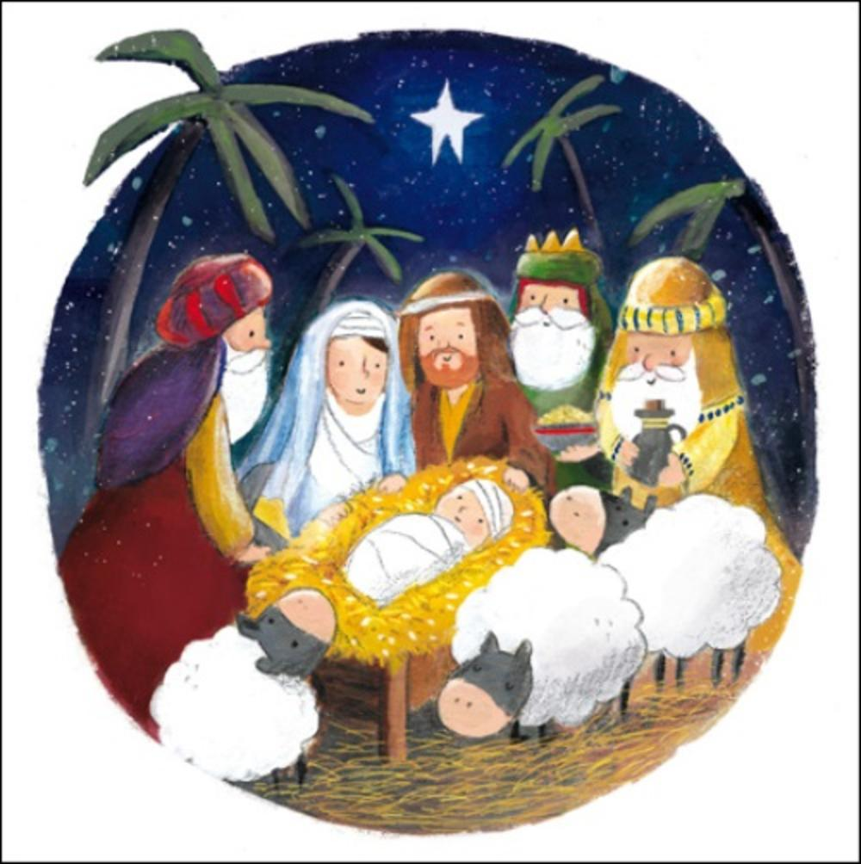
Home Learning
Big Enquiry:
What makes autumn special?
How does the birth of Jesus light up our winter?

Menu of Optional Activities

This half term our Big Enquiry combines two important aspects of the forthcoming season:
- What makes autumn special?
- How does the birth of Jesus light up our winter?
Some of you may wish to spend more time learning at home. So, we have written a menu of optional additional activities that you may wish to do. You could choose to do none, one or all of these activities during the half term.
Here is your menu of optional activities this half term:

- To make an autumn picture
- To create a leaf rubbing
- To go on an autumn walk and take a picture
- To collect conkers and use them to practice your number bonds
- To read and retell the Christmas story
- To make some Christmas gingerbread
- To make a Christmas decoration
- Read a story about Percy the Park Keeper for example, One Snowy Night or After The Storm.

Regular weekly home learning for all Year 1 children

Once again, to support your learning at school, home learning will focus on practising some very important key skills: reading, mental maths and spelling.
For reading, please just sign or initial for the day as we also ask you record what you have read in your reading log.
For spelling and mental maths, please make a note of what you practised e.g. Star words 1, number bonds to 10, 10 x tables etc.
We ask that you:
- Read at least 5 times a week to an adult for 10 minutes at a time.
- Practise your spellings 3 times a week (5-10 minutes per session).
- Practise your mental maths 3 times a week (5-10 minutes per session).
Here is an example of a completed grid.
EXAMPLE
Day | Reading | Spelling | Mental Maths
Saturday | Mum
Sunday |  | Bethany (big sister)  Set 2 words
Monday | Dad | grandad  Set 2 words
Tuesday | Dad |  | Nana  X10 table
Wednesday | Mum | grandad  Set 3 words
Thursday | Dad |  | Nana  X10 table
Friday |  |  | Dad  X10 table
Please use the table to record your home learning.

Weekly Spelling

In the national curriculum there are words which children in Year 1 are expected to be able to spell and independently apply in their writing.

We have grouped these words into sets of ‘stars’ and ‘planets’.

Throughout the half term we will assess how many of these spellings your child is able to spell independently and we will let you know how your child is progressing.

We would be very grateful if you could support your child to learn these spellings by starting with ‘star words’ – set 1. As your child becomes more confident with the words please feel free to progress through the 12 sets.

Star Spelling Words
Set 1:  a  I  the  is  his  like | Set 2:  so  do  no  go  to  today
Set 3:  be  he  me  we  she  made | Set 4:  said  as  has  of  you  very
Set 5:  by  my  was  were  where  came | Set 6:  saw  all  here  her  ask  have
Set 7:  with  went  when  what  there  make | Set 8:  that  this  then  them  they  back
Set 9:  are  our  your  one  once | Set 10:  love  come  some  friend  school
Set 11:  push  pull  full  put  foot | Set 12:  house  says  looked  called  asked

For reading, please just sign or initial for the day as we also ask you record what you have read in your reading log.
For spelling and mental maths, please make a note of what you practised e.g. Star words 1, number bonds to 10, 10 x tables etc.
We ask that you:
Read 5 times a week for 10 minutes at a time.
Practise your spellings 3 times a week (5-10 minutes per session).
Practise your mental maths 3 times a week (5-10 minutes per session).

WEEK 1
Day | Reading | Spelling | Mental Maths
Saturday
Sunday
Monday
Tuesday
Wednesday
Thursday
Friday

For reading, please just sign or initial for the day as we also ask you record what you have read in your reading log.
For spelling and mental maths, please make a note of what you practised e.g. Star words 1, number bonds to 10, 10 x tables etc.
We ask that you:
Read 5 times a week for 10 minutes at a time.
Practise your spellings 3 times a week (5-10 minutes per session).
Practise your mental maths 3 times a week (5-10 minutes per session).

WEEK 2
Day | Reading | Spelling | Mental Maths
Saturday
Sunday
Monday
Tuesday
Wednesday
Thursday
Friday

For reading, please just sign or initial for the day as we also ask you record what you have read in your reading log.
For spelling and mental maths, please make a note of what you practised e.g. Star words 1, number bonds to 10, 10 x tables etc.
We ask that you:
Read 5 times a week for 10 minutes at a time.
Practise your spellings 3 times a week (5-10 minutes per session).
Practise your mental maths 3 times a week (5-10 minutes per session).

WEEK 3
Day | Reading | Spelling | Mental Maths
Saturday
Sunday
Monday
Tuesday
Wednesday
Thursday
Friday

For reading, please just sign or initial for the day as we also ask you record what you have read in your reading log.
For spelling and mental maths, please make a note of what you practised e.g. Star words 1, number bonds to 10, 10 x tables etc.
We ask that you:
Read 5 times a week for 10 minutes at a time.
Practise your spellings 3 times a week (5-10 minutes per session).
Practise your mental maths 3 times a week (5-10 minutes per session).

WEEK 4
Day | Reading | Spelling | Mental Maths
Saturday
Sunday
Monday
Tuesday
Wednesday
Thursday
Friday

For reading, please just sign or initial for the day as we also ask you record what you have read in your reading log.
For spelling and mental maths, please make a note of what you practised e.g. Star words 1, number bonds to 10, 10 x tables etc.
We ask that you:
Read 5 times a week for 10 minutes at a time.
Practise your spellings 3 times a week (5-10 minutes per session).
Practise your mental maths 3 times a week (5-10 minutes per session).

WEEK 5
Day | Reading | Spelling | Mental Maths
Saturday
Sunday
Monday
Tuesday
Wednesday
Thursday
Friday

For reading, please just sign or initial for the day as we also ask you record what you have read in your reading log.
For spelling and mental maths, please make a note of what you practised e.g. Star words 1, number bonds to 10, 10 x tables etc.
We ask that you:
Read 5 times a week for 10 minutes at a time.
Practise your spellings 3 times a week (5-10 minutes per session).
Practise your mental maths 3 times a week (5-10 minutes per session).

WEEK 6
Day | Reading | Spelling | Mental Maths
Saturday
Sunday
Monday
Tuesday
Wednesday
Thursday
Friday

For reading, please just sign or initial for the day as we also ask you record what you have read in your reading log.
For spelling and mental maths, please make a note of what you practised e.g. Star words 1, number bonds to 10, 10 x tables etc.
We ask that you:
Read 5 times a week for 10 minutes at a time.
Practise your spellings 3 times a week (5-10 minutes per session).
Practise your mental maths 3 times a week (5-10 minutes per session).

WEEK 7
Day | Reading | Spelling | Mental Maths
Saturday
Sunday
Monday
Tuesday
Wednesday
Thursday
Friday

