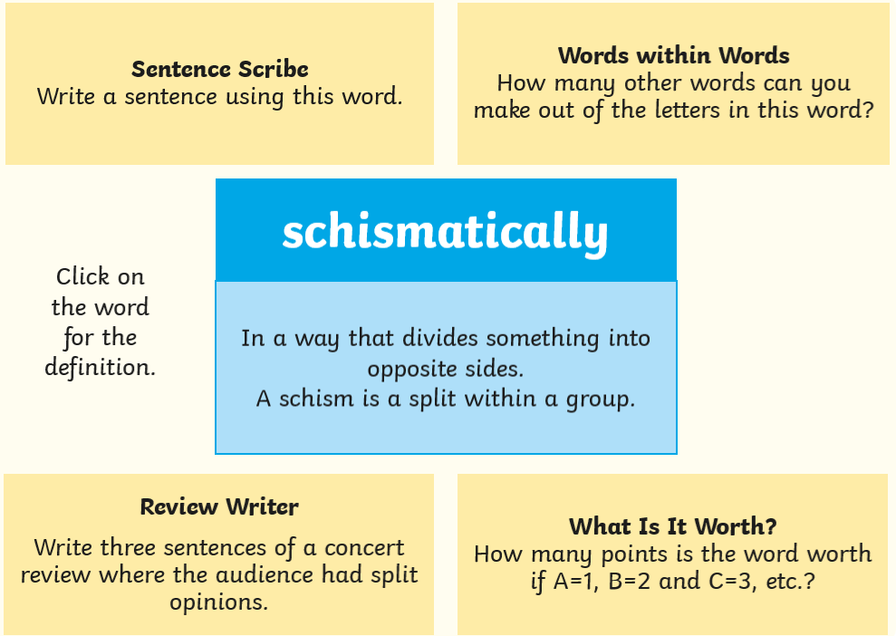
Year 6 Home Learning Checklist – Wednesday 1st July 2020
Week 5 (Summer Term 2)
Today’s Word of the Day is:

Today’s activities are: | ✓
Maths:
Today’s activity is to do with scatter graphs. Please look at the slides below (again, your teacher will take you through this if you are in school) and for your activity today draw the graph using the table on Slide 7.

https://app.mymaths.co.uk/358-lesson/scatter-graphs

There is also an activity about drawing line graphs uploaded to the school website – please use your own paper to create your own axes, not write on the sheet!
Production:
We are well on course to be filming our scenes over the first three days of next week. Today, we will continue to work in our groups with a particular focus on making sure our lines are learned and our performance is starting to flow a little better.

Remember to give yourself a tick when you have completed these activities too:
 | Read for at least an hour |  |  | Practise your mental maths (on TTRS?)
 | Practise your passport spellings (on Spellzone?) |  |  | Practise your handwriting
 | Keep active and exercise

Have a great day,
Mr Munro, Mrs Solomon & Mrs Skingle

